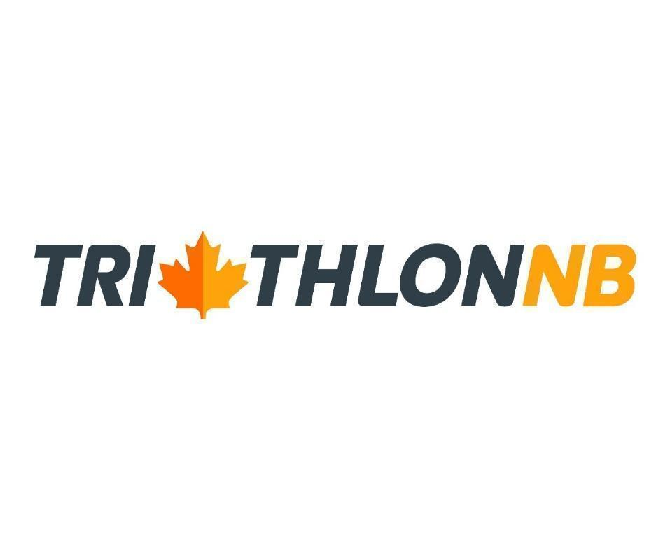
Triathlon NB ANNUAL GENERAL MEETING

October 27, 2022
Meeting Minutes

Mike Connolly, Maritime Regional Director  Doug Scott, President  Dave Young, Treasurer  Kristine Cormier  Marlo Rose | Althea Arsenault , Technical Director  Troy Kearns  Ricky Stiles  Chris Burke  Ben O’Donnell  Lisanne Maurice | Mallory Alty  Jim Currie  Rachel Fox  Isabelle Turner
- Doug Scott, President opened the meeting by thanking all those who attended. He noted that the meeting would be held in English but any comments or questions were welcomed in French.
  - Doug acknowledged that we on the traditional unceded territory of New Brunswick First Nations peoples.

- Meeting agenda was presented:
  - Althea Arsenault moved to adopt the agenda; seconded by Michael On

- Minutes of the last Annual General Meeting in 2021 (circulated)
  - Dave Young moved to accept the Minutes as presented; seconded by Ricky Stiles

- Doug noted that Rosemary Boyle, Secretary, would be stepping down from the Board.

- President’s Report (circulated) Highlights (Doug Scott):
  - 6 races in 2022 with 497 athletes competing
  - Mike Connolly, Maritime Regional Director was hired in the last year. Mike is based in PEI and was hired in shared services with Triathlon Canada, Nova Scotia and Tri PEI
  - 6 New Brunswick athletes competed in the Canada Games in Niagara Falls, ON
  - Continue to pursue closer ties with other Maritime Provincial Sports Organizations (PSO)
  - We are in a strong financial position

- NB Youth and Junior Program (Kristine Cormier)
  - Kristine reported the start of a new year for the Junior program due to start in November and run until August - September and October are off months.
  - Their program accepts youths aged 13-23 years. She noted that junior athletes must be 16 to participate in a Sprint but that Super Sprints or Try-a- Tri events are beneficial for athletes 13-16. She encourages Race Directors to include these shorter distances in their races to provide opportunities for younger athletes to develop their skills.
  - 6 athletes on the team participated this year despite training challenges presented by COVID-19
  - The team was able to travel to Joliette, Quebec and Summerside, PEI to race
  - Their training program consists of developing specific skills like open water sighting, buoy turns, mount and dismount skills, bike cornering, emergency stopping, running form and effective transitioning
  - 3 top athletes received awards. Emerson Scott was the top female winner. Emerson finished 1st in her age group and 6th overall in Harvey and 25th overall at the Canada Games. Yannick Dupuis was the top male. He finished 1st in his age group in Sackville, 2nd place overall in Harvey and 2nd place in PEI. He finished 16th at the Canada Games but was 5th out of the water. He plans his first 70.3 in 2023 at Mt. Tremblant. The 3D (Determined, Dedicated and Devoted) winner went to William Banfield. He place 1st overall in PEI TriLobster Super Sprint in Summerside. Congrats to these 3 athletes!
  - Doug commended the youth coaching team - Kristine Cormier, Ricky Stiles and Michael On for their dedication and commitment to these young athletes.

- Technical Director’s Report - Althea Arsenault
  - PTO Level 1 course offered at the end of May with 4 new officials entered onto the roster. Ken Drake, Kym Elder, Ben O’Donnell and Steve Sarnelli are now PTO1s. Of note, 2 Race Directors also participated in the course. We were lucky enough to have a BC official, Andrew Armstrong join the official ranks as well.
  - 7 races were sanctioned this year. Sanctioning process ensures that a race is safe and fair. The races were Hampton, Rockwood, Mike’s Bike Shop Kids of Steel, Harvey, Arboiteau, Cambridge Narrows, Sackville.
  - Goals for Fall of 2022, Spring of 2023 will be on recruiting and training additional officials.

- Maritime Regional Director’s Report (circulated)
  - New report out in NB on the sport system. Changes to system will be implemented. GAINING MOMENTUM TOGETHER – Envisioning N.B. Sport 2035. The report resulted in over 60 recommendations for sport system change. It emphasizes the need for collaboration within and outside the traditional sport system and Sport NB strongly believe success will result in:
    - Increasing participation in quality commentative sport
    - Increase assistance to competitive athletes
    - Increase support to volunteers, leaders and organizations
    - Increase use of sport to achieve health, social and economic benefit
    - New partnerships on the horizon - Swim team in Moncton, potential to do something with Para Sport NB
  - Have been working with other Maritime provinces on joint initiatives:
    - Increase number of officials
    - Sponsorship - efforts have been unsuccessful mostly owing to the post COVID climate
    - Winter race series
    - Standardization of officials’ costs
    - Coaching courses
    - Race Directors guidance development
    - Technical Director and Race Director race evaluation form
    - NTO course linked to a Maritime race
  - Draft Safe Sport policies developed as required by province
  - Insurance
  - Virtual series during the Winter went well
  - World spots obtained at Sackville and Harvey
  - GNB has provide $5,000 to hold a Winter triathlon - Doug Scott and Doug Barrett will be planning this - venue not chosen yet but will be in Southern NB
  - Mike met with Joe Morrisette, CEO of Triathlon Canada along with other PSO members. Triathlon will not be included in the next Canada Games. Tri Can will be looking to build capacity in the sport across the country.
  - Coaching course coming up in Halifax
- 2022 Races
  - Doug reported that NB has 6 races and 497 athletes in 2022. Compared to 2019 - pre COVID - where there were 11 races and 1231 athletes participating. He emphasized that we are still recovering from COVID and this will require a collaborative effort.
  - Top Male and Female Athletes - These decisions, in previous years, were made differently. Earlier in the year, the Board decided, due to the uncertainties presented by COVID, that simpler criteria would be used to make the choice. The criteria were:
    - Had to do at least 21 NB races
    - Had to have full membership
    - Had to be NB residents
    - Points were awarded for top 5 finishers with 1st place finish awarded 5 points, 2nd place - 4 points, 3rd place - 3 points, 4th place - 2 points and 5th place - 1 point.
    - Based on this criteria, the top female was Sarah Quinton and the top male was Keiran Everett. Congratulations to both - they will each receive a $100 gift card.
- Financial Report (circulated)
  - Dave Young reported on the fiscal year of 2021. Our account was healthy at the end of 2021 owing primarily to GNB’s continued support through their unchanged sport grant and decrease in expenses for the year.
  - Carolyn Prebble reviewed and prepared the statements in accordance with our by-laws.
  - Need to reinvest our grant money in ways that give us long term benefits for our athletes and races.
  - Motion to accept the financial statements was made by Dave Young, seconded by Althea Arsenault.
- Board Election
  - The Board can have up to 12 members. 7 members are returning (Doug Scott, Dave Young, Troy Kearns, Marlo Rose, Kristine Cormier, Althea Arseanault and Ben O’Donnell) - all have 1 year remaining in their terms. There are 3 members re-offering (Ricky Stiles, Chris Burke and Lisanne Maurice) and 2 who have offered their names to sit on the Board (Jim Currie, Isabelle Turner).
  - Doug Scott for any new Board members. Mallory Alty put her name forward. Because of the 12 maximum with 7 returning members in the middle of their terms, there is space for 5 more members with 6 offering. The voting process will be as follows: All who have offered for the 5 open positions provide a 2 minute background/description as to what they can offer the Board. Voting will be done via the chat function - all members will enter 5 names in the chat box. Mike Connolly will count votes and relay to Doug. Only those who are registered for the AGM and are annual members are eligible to vote as per our By-laws.
  - Chris Burke withdrew his name from contention making the 5 positions to be occupied by Ricky Stiles, Lisanne Maurice, Jim Currie, Isabelle Turner and Mallor Alty.
  - Doug gave the new Board members an opportunity to introduce themselves to the Board - Isabelle Turner, Mallory Alty and Jim Currie.
Annual General Meeting adjourned

